The State of Global Outreach
By Bill Moberly
From the Editor, April 2026

What Is the State of Global Mission Outreach?
As I began writing this article, the President’s “State of the Union” address was about
24 hours away. Even with the current deep polarization in U.S. politics, this
address is an important part of our governmental framework and our history.
It dates to 1790 with the first report given by President George Washington,
fulfilling the constitutional requirement for the President to inform Congress
about the state of the nation. Article II, Section 3 of the U.S. Constitution
requires the president to “from time to time give to the Congress Information
of the State of the Union and recommend to their Consideration such Measures
as he shall judge necessary and expedient”.

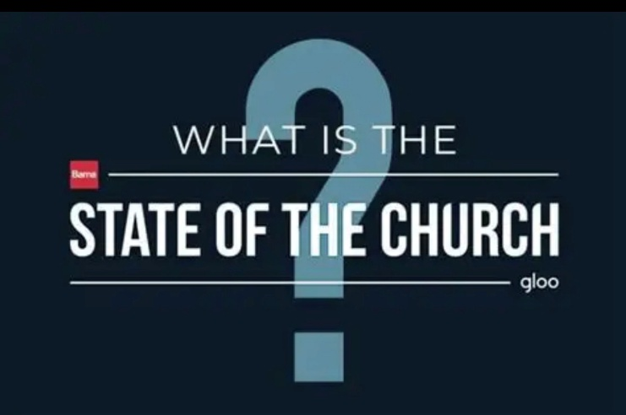
If our country needs an annual update on the ‘state of the nation’, how much more do Christians need a report on the status of Jesus’ command to His church to “Go and make disciples of all the nations” (‘ethne’) (Matthew 28:19). The Barna Research Group published an in-depth study by that name in 2021 which is fascinating and insightful, but outside the scope of this writing. The most disturbing finding was that only 17% of church attenders ‒ fewer than 1 in 5 ‒ had heard of the Great Commission and actually knew what it meant!

What Is the State of the World?
My question: how is the work progressing globally? Where are those with little or
no access to the Gospel? What is the “State of the World”? This is a Global snapshot
summarizing the work carried out by national leaders, missionaries, mission agencies,
and churches around the world. It is what is being done and taking stock of what remains!
Considering the ‘state of the world’, we also need to personally and congregationally look
at what we are doing, are not doing, and how we are practically and personally engaged in
the global mission mandate given by the resurrected Christ to His Church!


One key source for this Global Assessment comes from the Lausanne Movement, which held its Fourth Congress on World Evangelization in Incheon, Korea in September 2024. Pastor Tom & Deuane Thorstad, part of our ALWM team serving in Laos, were in attendance, looking at gaps and opportunities in global mission as 2033, and then 2050 get ever closer. Was I just a little envious? Yep! The first gathering was in 1974.

“Billy Graham’s global travels revealed a disconnection among Christian leaders,
prompting him to convene the First International Congress on World Evangelization
in Lausanne, Switzerland in 1974. This sparked a movement characterized by humility,
friendship, prayer, and partnership, known as ‘the spirit of Lausanne’, and led to further
global gatherings, collaboration, and strategic efforts that would shape global mission
for the next five decades and beyond.”

Important missiological terms such as ‘people groups’ and ‘quantifying the least reached/unreached peoples that inform and shape global mission’, were not new concepts but were brought forward into focus as a part of the impetus flowing from Lausanne, 1974. The Lausanne movement the past 50 years has been rooted in the idea of assessing where we are in Global mission and what remains to be done. (Visit Lausanne.org for valuable and interesting information!)

Current Global Mission Statistics
The Traveling Team is an evangelical mission ministry working on college campuses to mobilize young people to answer God’s call to the nations. It is a reliable source for a wide range of helpful and sobering statistical information about the current state of Global mission world-wide.
Here are just a few of the stats found there:

WORLD-WIDE POPULATION

GLOBAL (updated FEB 2024)
- 8.12 billion
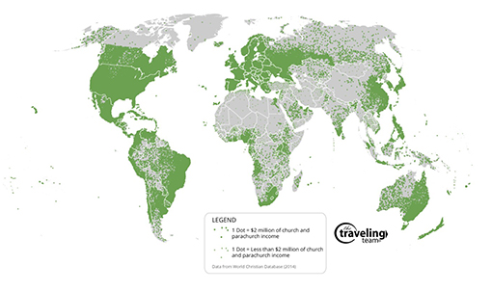
- Median age - total: 30 years
- Life expectancy - total population: 67 years

TOP TEN MOST POPULOUS COUNTRIES
- India 1.43 billion
- China 1.42 billion
- United States 341 Million
- Indonesia 279 Million
- Pakistan 243 Million
- Nigeria 227 Million
- Brazil 217 Million
- Bangladesh 173 Million
- Russia 144 Million
- Mexico 129 Million
Total People Groups: 17,281

UNREACHED PEOPLE GROUPS
- Less than 2% Evangelical Christian.
- Total Unreached People Groups: 7,246
- Total Population of UPGs: 3.39 billion people
- Total Percentage of world: UPG’s make up 41.8% of world population

UNEVANGELIZED PEOPLES
- Greater than 2% Evangelical Christian but still great numbers of unsaved.
- Total Unevangelized People Groups: 2,906
- Total Population: 799.7 million
- Total Percentage of world: the unevangelized make up 9.9% of world population

REACHED PEOPLES
- Greater than 2% Evangelical Christian or majority Christian Population
- Total Reached People Groups: 7,129
- Total 82% goes to Home ministries of local churches (mostly Christian nations): $1 trillion [2]
- 12% goes to Home Evangelism in same Christian Population: 3.8 billion
- Total Percentage of world: the reached population makes up 46.9% of world population

STEWARDSHIP WITHIN CHRISTIANITY

WHAT CHRISTIANS EARN:
Annual Income of all Church Members: $70 trillion. [1]

WHAT CHRISTIANS GIVE:
Only 1.86% is “tithed” to any Christian causes: $1.3 trillion.

HOW ARE MINISTRY DONATIONS USED:
- nations: $156 billion [2]
- Only 6% of this “tithe” goes to general Missions: $78 billion

WHAT MISSIONS MONEY IS USED TO REACH THE UNREACHED?
- Only 1.7% of “Missions Giving” goes to work among Unreached Peoples Estimated $1.32 billion (1.7% of the $78b for general “missions”) [3]
- For every $100,000 that Christians make, they give $1.83 to the unreached.
If you were in a ballroom with a fifty-foot ceiling and the ceiling represented what Christians earned, you could stand two dollar bills, end to end, 12” from the floor to represent what Christians tithe. But to see how little is used for the unreached you would have to stack both bills and lay them flat. (roughly 1/2 mm).⁴

I was a math major in college, so I do enjoy statistics. They are not everyone’s
favorite thing, but they often do paint a picture. The story told here is about
misplaced priorities and redeployment of resources, especially when it pertains
to working among those unreached and least reached with the Gospel. These
include places where ALWM, the agency I serve, works – for example, in
places like Bangladesh, Belarus, Cambodia, Laos, Myanmar and Vietnam.
Only 1.7% of missions giving goes to ministry to the unreached! In addition,
the ratio of full-time Christian workers to Christians in the reached world is
about 1:450, while in the unreached world the ratio of missionaries to the
unreached population its about 1:255,000. (That statistic was among the
many things God used in my life as He called me from parish ministry to
global mission ministry full-time in 2004.)

What Is Your Role?
Where do you fit? What is your role in God’s global call to the nations?
Does your congregation weigh any of these factors as it considers global
mission? My experience with over 35 years in global mission, the last 22
full-time, is that in our Lutheran family many of these concepts unfortunately
are relatively unknown.

Yet these concepts and others like them are essential for meaningful, strategic, and effective global mission involvement! Informing and inspiring national leaders and congregations in our Lutheran family about the actual ‘state of the church’ in global mission is why the Lord led me to establish ALWM in 2007, expanded it in 2015, and with the leadership of Rev. Kent Groethe helped launch CGM Magazine in 2021!

I invite you to read my Ideas from Churches article in this issue as I suggest
practical ways to get a snapshot of the “State of Global Mission” in your own
congregation.

In Christ for the nations,
Bill Moberly, CGM Editor


Rev. Bill Moberly, director of Awakening Lives to World Missions (ALWM), helps churches with global mission outreach. He authored Igniting a Passion for Missions: A Guide for Church Leaders. He and wife Sally have 7 children, 21 grandchildren, 2 great-grandchildren, and have traveled to 23 countries to share the Gospel and equip leaders.

Contact Bill at: pastorbill@alwm.org

Links:
State of the Union: State of the Union | Meaning, Address, History, & Designated Survivor | Britannica
Barna: https://www.barna.com/research/missions-evangelism
Movement: https://lausanne.org/about
Visit: https://lausanne.org/
ALWM: https://www.alwm.org/
The Traveling Team: https://www.thetravelingteam.org/
Stats: https://www.thetravelingteam.org/stats
CGM: https://www.cgmmag.com/
Article: https://www.cgmmag.com/wp-content/uploads/2026/03/GlobalOutreachClearGoals_BillMoberly_IdeasFromChurches_April2026.pdf

